Chapter 11, Problem 27.

Calculate the rms value of the current waveform of Fig. 11.58.

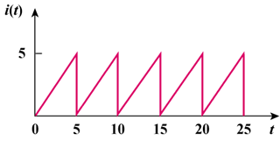

Figure 11.58
For Prob. 11.27.

